**A brief introduction to asset mapping**

Asset mapping is a way of visually representing an individual’s or a community's assets. Asset mapping, as a methodology, emerged out of the principle of asset-based community development, the premise that communities will be better equipped to develop their project if they can identify and mobilise the assets they already have (which often are unrecognised). This allows them to respond to and build on these existing capabilities rather than focusing on what they don’t have (Mathie and Cunningham 2002, McKnight and Kretzmann 1996).

Assets can be different things:

* People (e.g. An individual’s skills, knowledge, time, associations)
* Spaces (e.g. library, park)
* Groups (e.g. recreational, support groups)
* Cultural identity (e.g. history, diversity, annual festival)
* Community Services (e.g. council, local government)
* Media (e.g. local newspaper, noticeboards, online forums)
* Businesses / local industry

As part of our Creative Citizen project ([www.creativecitizens.co.uk](http://www.creativecitizens.co.uk)) we will be developing and using an asset mapping methodology to understand opportunities for media interventions in community-led design projects and evaluate their impact.

As well as being a research methodology for this project, we envisage the asset maps to be useful artifacts in themselves helping the participating communities visualise and identify future opportunities. Consequently effort will be made to present these in an accessible and visually compelling way and to make these available to each of the communities.

**These are some inspiring examples of asset maps:**

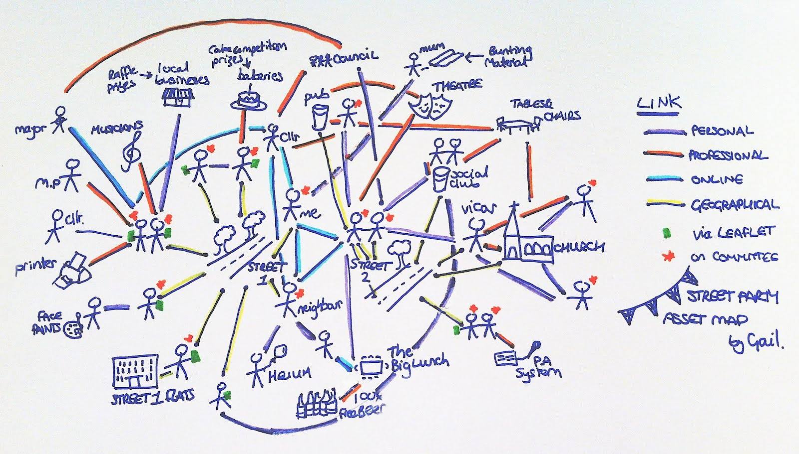

[Commissioned illustration of Govanhill’s asset map - http://thrivingtoo.typepad.com/thriving_too/assets/](http://thrivingtoo.typepad.com/thriving_too/assets/)

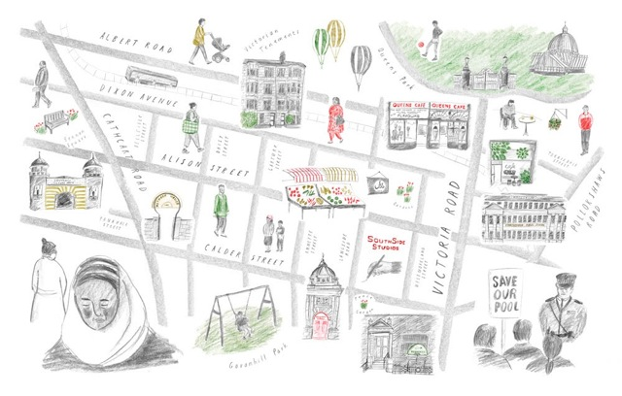

Rough sketch of the assets of a community group who are organising a street party <http://creativecitizens.co.uk/community-led-design/community-asset-mapping-and-a-jubilee-street-party/>

**References**

Mathie, A. and Cunningham, G. (2002) ‘From clients to citizens: Asset-based community development as a strategy for community-driven development’ ThevCoady International Institute, St. Francis Xavier University, <http://www.coady.stfx.ca/resources/publications/publications_occasional_citizens.html>

McKnight, J. and Kretzmann, J. (1996) ‘Mapping community capacity’ Institute for Policy Research, Northwestern University